# Activity JavaScript Questions

## Question 1:

Create a simple web page with the following features:  
  
1. An input box where the user can type their name.  
2. A button labeled "Greet Me".  
3. When the button is clicked, display a message below the button that says:  
 "Hello, [name]!", where [name] is what the user typed.

Code:

<!DOCTYPE html>

<html>

<head>

  <title>Greet Me</title>

</head>

<body>

  <h2>Enter your name:</h2>

  <input type="text" id="nameInput" placeholder="Your name">

  <button onclick="greetUser()">Greet Me</button>

  <p id="greetingMessage"></p>

  <script>

    function greetUser() {

      const name = document.getElementById("nameInput").value;

      document.getElementById("greetingMessage").innerText = "Hello, " + name + "!";

    }

  </script>

</body>

</html>

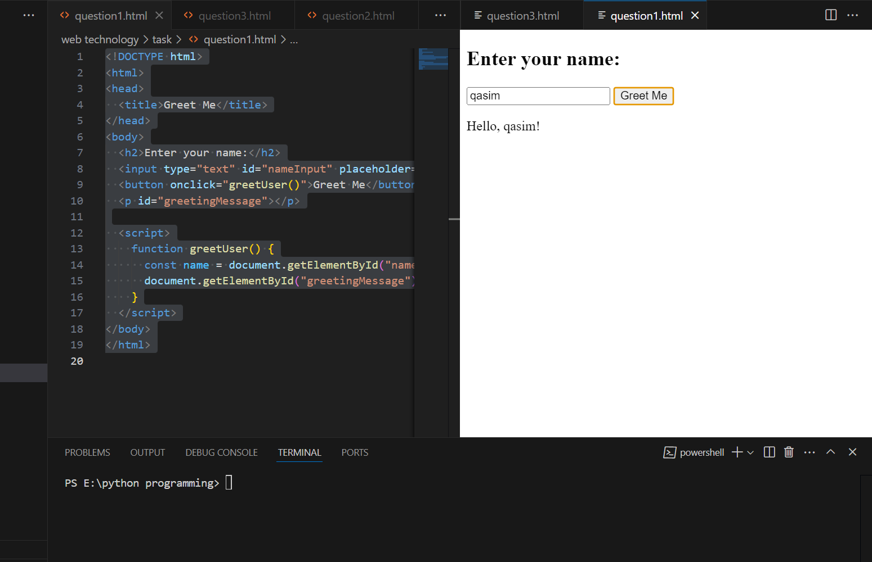

## Question 2:

Create a simple webpage with the following features:  
  
1. A button labeled "Show Date".  
2. When the button is clicked, display the current date and time below the button.

<!DOCTYPE html>

<html lang="en">

<head>

    <meta charset="UTF-8">

    <meta name="viewport" content="width=device-width, initial-scale=1.0">

    <title>Document</title>

</head>

<body>

    <h2>Click to see current date and time:</h2>

  <button onclick="showDate()">Show Date</button>

  <p id="dateDisplay"></p>

  <script>

         function showDate(){

             const currentDate = new Date();

            const date=document.getElementById("dateDisplay").innerText=currentDate.toString();

         }

  </script>

</body>

</html>

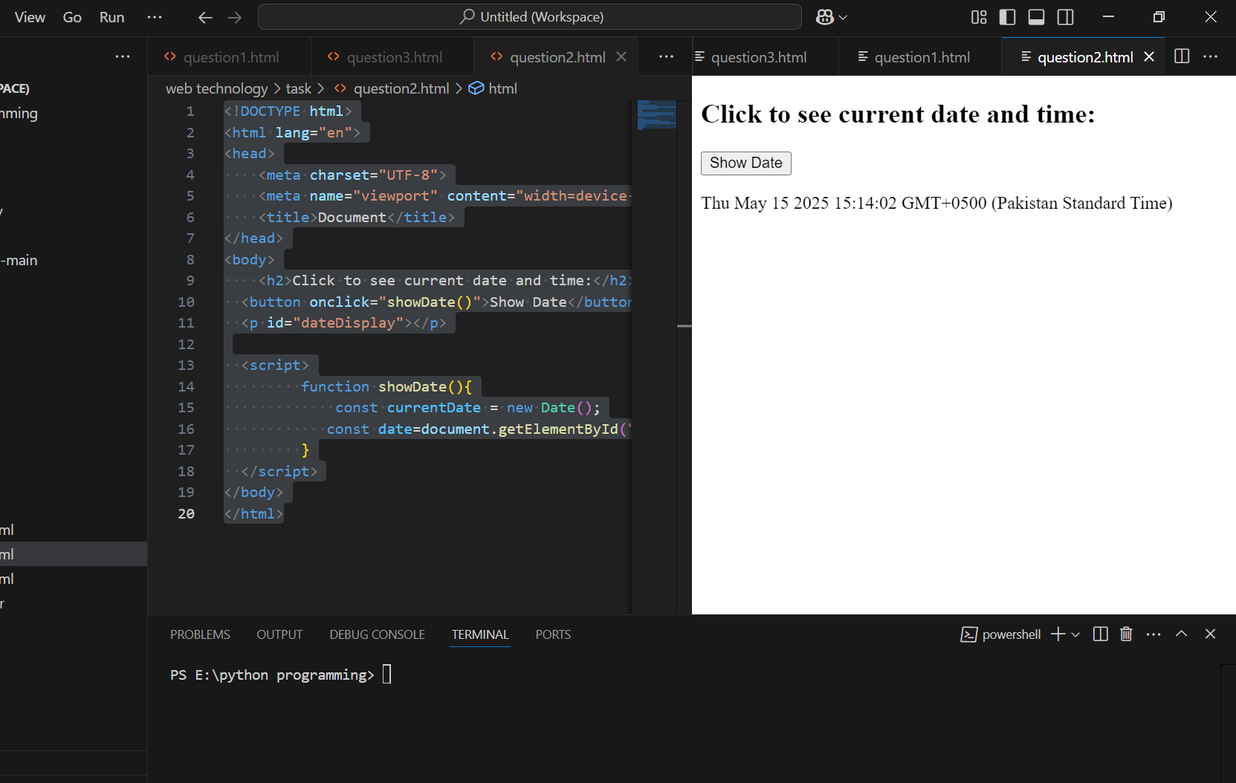

## Question 3:

Create a simple webpage with the following features:  
  
1. Two input boxes for numbers.  
2. A button labeled "Add Numbers".  
3. When the button is clicked, display the sum of the two numbers below the button.

<!DOCTYPE html>

<html>

<head>

  <title>Calculate Sum</title>

</head>

<body>

  <h2>Calculate Sum</h2><br>

  <label for="numinput1">Enter 1st number:</label>

  <input type="number" id="numinput1" placeholder="Enter a number"><br><br>

  <label for="numinput2">Enter 2nd number:</label>

  <input type="number" id="numinput2" placeholder="Enter a number"><br><br>

  <button onclick="calculate()">Calculate Sum</button>

  <p id="sum"></p>

  <script>

    function calculate() {

      const num1 = Number(document.getElementById("numinput1").value);

      const num2 = Number(document.getElementById("numinput2").value);

      const sum = num1 + num2;

      document.getElementById("sum").innerText = "Sum = " + sum;

    }

  </script>

</body>

</html>

